**Treasures in Heaven**

**Reading:** Matthew 6:19-21

Jesus said, “Do not gather for yourselves riches on earth. Moths and rats can destroy them. Thieves can break in and steal them. Instead gather for yourselves riches in heaven. There, moths and rats do not destroy them. There, thieves do not break in and steal them. Your heart will be where your treasure is.”

**Thought about the reading**

We can spend lots of money buying nice things, like smart phones, pretty clothes, fast cars. These can become like treasure to us, things that we think are very important in our lives. But Jesus said that we can lose these things in a moment. The smart phone might get broken, moths might eat holes in the clothes and the car might get stolen by thieves. Then we have lost our treasure.

In the reading, Jesus said we should gather riches in heaven, because that treasure will not get broken or stolen, but will last forever. How do we do that? We can’t send things up to heaven!

Jesus told a story about a woman who was very poor, but she gave away her last two coins. Jesus said that she gave more then the rich people who kept some money to pay for the things they wanted and gave a bit from what was left over. She gave more because she gave everything she had. She was not gathering money on earth, but riches in heaven.

Whenever we give what we have, it is like we are putting treasure into heaven. This does not mean just giving money. We can give our time to help people. We can give a smile to someone who needs cheering up. We can give a hug to someone who feels lonely. We can give a cup of tea to someone who needs a break.

**Prayer**

Lord Jesus, thank you that you gave everything for me.

Please show me what I can give. Help me to give generously, so that I can gather treasures in heaven.

Amen

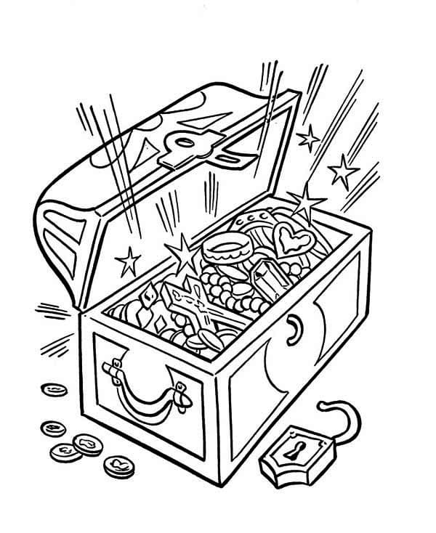

**Cambridge Causeway**

Summer 2023

Bible Study notes

**The Sermon on the Mount**

**4. Treasures in Heaven**

By Chrissy Cole